PATENT APPLICATION INVENTION DISCLOSURE FORM

● For UNIVERSITY & CORPORATE inventors: Fill in all parts, and make sure that the invention disclosure is signed, witnessed and dated.

● For INDIVIDUAL INVENTORS: There is no need to have the disclosure witnessed and dated.

1) INFORMATION FOR ALL INVENTOR(S)

Inventor (full name) Fei Fang
Citizenship Hong Kong (China)
Address ‘phone, email and fax +1 360 869 0169, fei.aaron.fang@gmail.com

2) TITLE OF INVENTION

3) DATE OF FIRST WRITTEN DESCRIPTION OF INVENTION
June 23, 2025

4) LOCATION OF WRITTEN RECORD (e.g. Lab book No., page)
Personal device

5) HAS THE INVENTION BEEN TESTED ON AN EXPERIMENTAL BASIS? (Describe when, where, and the results)
Yes, June 1-25, tested online

6) HAS THE INVENTION BEEN DISCLOSED TO PERSONS OUTSIDE YOUR UNIVERSITY/COMPANY? If yes, say to whom, when, and relationship to company/university. Also, please tell us if a non-disclosure agreement was signed.
No

7) THE INVENTION

a) What is the goal/problem that the invention addresses?

The invention addresses two interconnected problems: (1) ADHD children need cognitive behavioral training as recommended by CDC/AAP, but traditional therapy has barriers that prevent access, and (2) ADHD children struggle with math learning due to attention deficits, creating a cycle where poor attention hurts academic performance and poor academic performance hurts self-esteem and motivation.

b) What is the currently used solution to meet this goal / solve this problem?

7 million (11.4%) U.S. children aged 3-17 years have been diagnosed with ADHD (source: CDC https://www.cdc.gov/adhd/data/index.html)

These students face well-documented academic challenges:
- Lower standardized test scores in mathematics compared to neurotypical peers
- Reduced GPA: averaging 25% lower than non-ADHD students
- Higher rates of grade retention and special education placement
- Increased school dropout rates: 32.2% vs 15% for non-ADHD peers

Current solutions include:
- ADHD therapy: In-person cognitive behavioral training with specialized therapists
- EndeavorRx (FDA-cleared digital ADHD therapeutic): Video game-based attention training using abstract tasks, but doesn't address academic skills or use educational content; gamified content is not universally accepted by parents
- ADHD medications: Adderall/Ritalin improve attention but don't directly address academic learning gaps; parents hesitate with medication due to side effect concerns
- Educational apps: Khan Academy, IXL, etc. for math learning but without attention monitoring or therapeutic intervention; these are generic study tools without ADHD-specific tailoring or real-time adaptation
- Academic tutoring: Lack ADHD-specific attention training protocols or therapeutic intervention

c) What are the shortcomings/disadvantages of the current solution?

Systemic gap: No current solution combines therapeutic attention training with academic skill development. The real challenge for families with ADHD children is academic performance - their child's success in school is the primary concern. Existing solutions tend to address attention training without academic benefits (EndeavorRx, traditional therapy). No solution directly targets both the underlying attention issues and the academic struggles that matter most to families.

Traditional ADHD therapy:
- Cost barrier: $100-200/hour excludes most families
- Time burden: 60+ minute sessions plus commute time
- Access limitations: Limited availability of specialized ADHD therapists
- Single focus: Addresses attention only, no academic skill development
- Subjective measurement: Progress based on therapist observations, not objective data

EndeavorRx digital therapeutic:
- No academic benefit: Abstract gaming tasks don't transfer to classroom learning
- Parent resistance: Many parents prefer academic-focused over entertainment-based interventions

ADHD medications:
- Side effect + dependency: Parents worry about appetite suppression, sleep issues, growth impacts; benefits disappear when medication stops
- No academic remediation: Doesn't address existing learning gaps or build math skills

d) What is the new solution to the problem (i.e., your invention)?
Particularly:

- Describe a detailed structure of the invention disclosing each element (mechanical, electronic, informational, methodological or chemical), exactly how it fits to, contacts and/or works with other elements, and what it does. Include a detailed and labeled diagram if available.

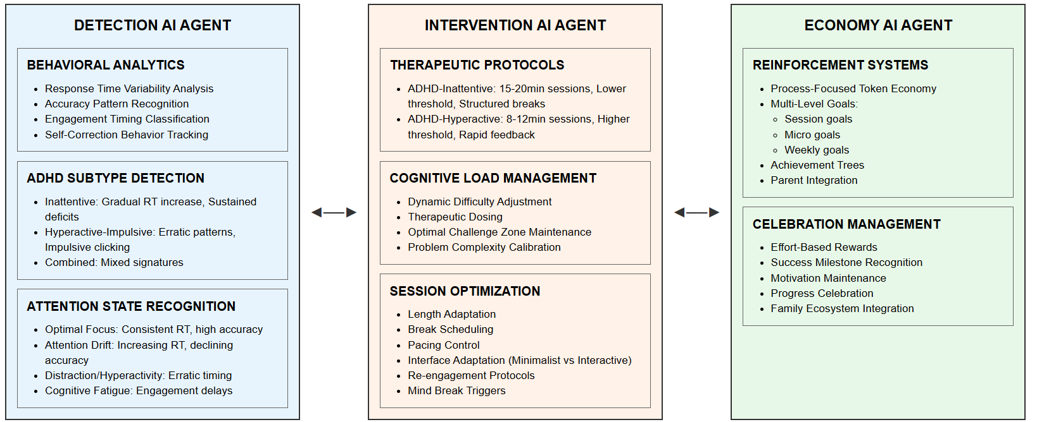

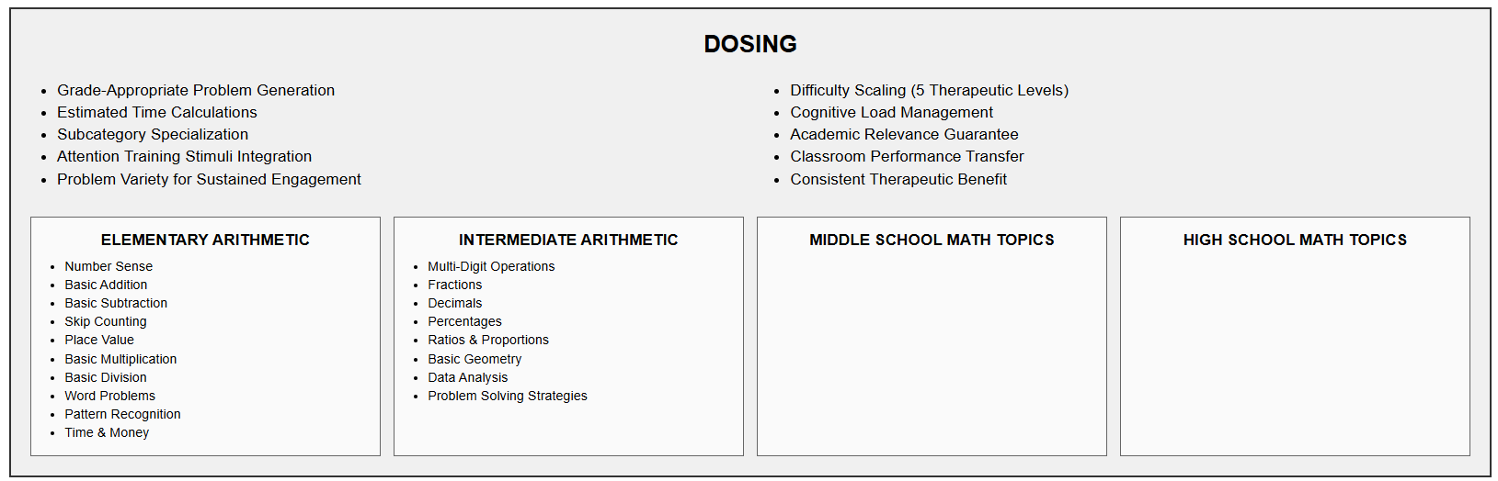

Key AI agent designs (therapeutic personalization)

Detection Agent: adaptive cognitive load monitoring
The Detection Agent continuously watches math performance to understand each child's attention capacity:
Real-time difficulty adjustment based on attention capacity indicators
- AI monitors response times every problem to detect attention changes
- Automatically reduces cognitive load when accuracy drops below certain threshold (e.g. 70%)
- Increases complexity when accuracy above certain threshold
- Learns individual starting points and adapts within each session
Attention pattern recognition through behavioral analysis
- Detects focus loss through response time variability and accuracy decline patterns
- Distinguishes between different types of mistakes (careless vs. knowledge gaps)
- Tracks engagement timing and self-correction behaviors
Examples of AI adaptivity:
- Child A: High accuracy but slow processing → AI increases time allowance
- Child B: Fast but careless → AI adds accuracy incentives
- Child C: Strong start, quick fatigue → AI schedules shorter, more frequent sessions
- Child D: Avoids difficulty → AI creates gradual challenge progression

Intervention Agent: personalized delivery protocols
The Intervention Agent deploys different therapeutic approaches based on ADHD subtype:
ADHD-Inattentive Protocol:
- 15-20 minute sessions with structured consistency
- Scheduled 3-minute breaks managed by AI
- Small incremental difficulty steps (10-15% increases)
- Lower threshold (65%) before AI reduces difficulty
- Minimalist interfaces with calm colors and extended processing time
ADHD-Combined/Hyperactive Protocol:
- 8-12 minute sessions in one sitting
- Variable difficulty to maintain engagement
- 75% challenge target with speed considerations
- Interactive interfaces with energizing colors and immediate response acknowledgment

Economy Agent: Goal and Reward Management
The Economy Agent handles motivation and progress tracking:
Multi-level goal system:
- Session goals: "stay focused for next 7 minutes", "take a 3-min break", "complete 8 problems carefully"
- Micro goals: "answer this question in 30 seconds", "check your work" with virtual pointer
- Weekly goals: "study 10 mins a day", "complete work at >70% score", "focus on multiplication"
Token economy system:
- Process-focused reinforcement: 1 point per sustained minute of focus
- Completion bonuses: 5 points for accuracy streaks
- Achievement progression: Effort-over-correctness celebration, skill tree advancement
- Parent-controlled reward systems: screen time, privileges determined by parents
Parent empowerment tools:
- Automated training management: AI handles difficulty/time adjustment
- Performance tracking: Real-time grading and progress reports
- Student independence: AI explanations for wrong answers, hint systems

Data Strategy: What AI agents track
Detection Agent monitors:
- Response time patterns (normal 3 seconds → suddenly 8 seconds = attention drop)
- Accuracy trends (9/10 correct → 3/10 correct = distraction)
- Time between problem presentation and first interaction
- Self-correction frequency (going back to change answers)
- Performance consistency within sessions (steady pace vs erratic timing)
- Mathematical error pattern analysis (careless mistakes vs. knowledge gaps)
- Session abandonment and problem-skipping behavior
- ADHD subtype indicators (impulsive-hyperactive vs. inattentive patterns)

Process Strategy: Attention state-based intervention

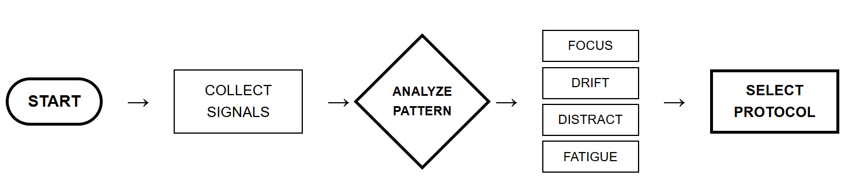

Optimal Focus State
Detection Agent indicators:
- Response times: consistent in seconds
- Accuracy: Good with thoughtful errors
- Immediate engagement: small gaps between problems and between click and input
- Effective self-corrections
Subtype variations detected:
- Inattentive subtype: Slightly slower but consistent time on each problem
- Hyperactive-impulsive subtype: Faster responses though accuracy may vary
Intervention Agent response - Challenge protocol:
- Gradually increase math complexity
- Extend session length slightly
- Inattentive: Allow longer response windows
- Hyperactive-impulsive: Provide immediate success feedback for sustained focus

Attention Drift State
Detection Agent indicators:
- Response times: Increasing from 15 → 35 → 55 seconds
- Accuracy: Declining gradually
- Inaccurate self-corrections, second-guessing
Subtype variations detected:
- Inattentive subtype: Gradual response time increase, longer delays before interaction
- Hyperactive-impulsive subtype: Increasing restlessness (rapid clicking), inconsistent timing
Intervention Agent response - Re-engage protocol:
- Add visual variety to problem presentation
- Provide encouraging feedback
- Inattentive: Gentle audio or visual cues to refocus
- Hyperactive-impulsive: Quick success problems to rebuild momentum

Distraction/Hyperactivity State
Detection Agent indicators:
- Response times: erratic (20 seconds, then 5 seconds, then 25 seconds)
- Impulsive clicking patterns
- Problem-skipping behavior
Subtype variations detected:
- Inattentive subtype: Long pauses with no interaction, delayed responses >10 seconds, minimal engagement
- Hyperactive-impulsive subtype: Random clicking, problem skipping, high self-correction frequency
Intervention Agent response - Mind break protocol:
- Pause session with "brain break" message
- Switch to simple problems (confidence builders)
- Reduce visual distractions on screen
- Inattentive: Gentle prompting ("Ready for the next one?"), simplified presentation, shorter problems
- Hyperactive-impulsive: Movement break suggestion, slower problem presentation (1 problem per page)

Cognitive Fatigue State
Detection Agent indicators:
- Engagement delay: Growing longer over time
- Giving up on problems, minimal self-correction, passive behaviors
Intervention Agent response - Wrap up protocol:
- End session with success (easy final problems)
- Praise effort and consistency
- AI adjusts session timing for next time

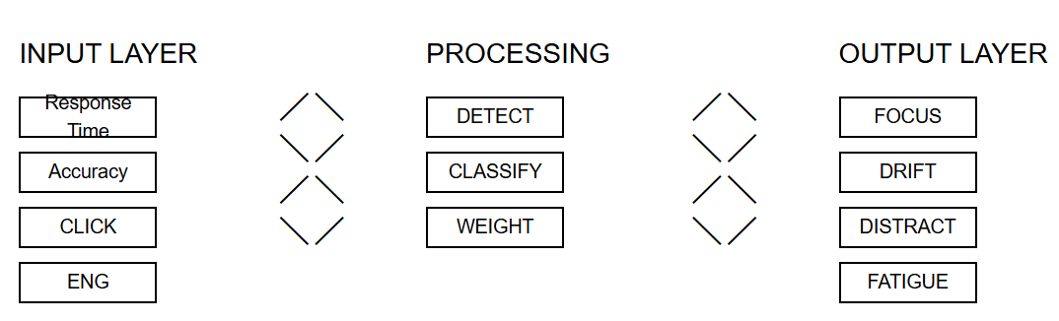

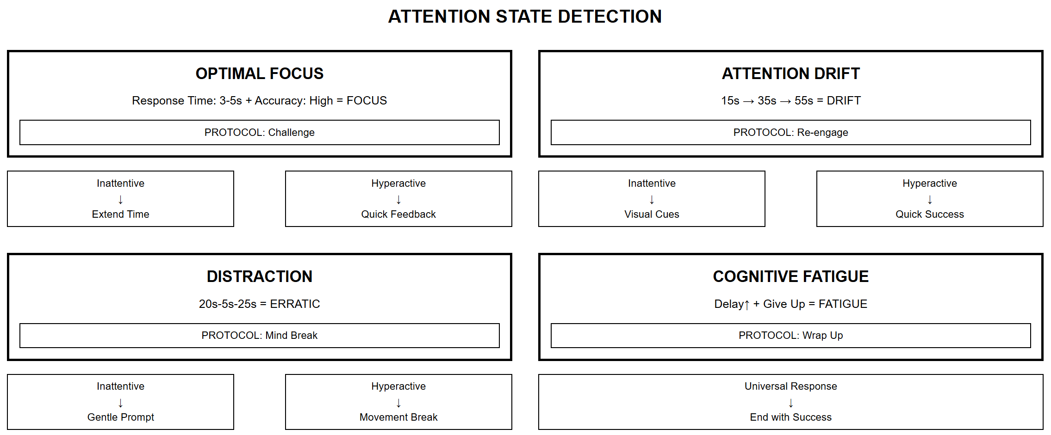

Outcomes
Attention improvement
Sustained attention duration (time in optimal focus state)
Attention consistency (reduced variability in response times)
Distraction recovery time (how quickly child refocuses)
Session completion rates over time

Mathematical progress
Error patterns (careless mistakes → improved accuracy)
Confidence indicators (self-correction patterns)
Understanding of knowledge gaps and advancement tracking

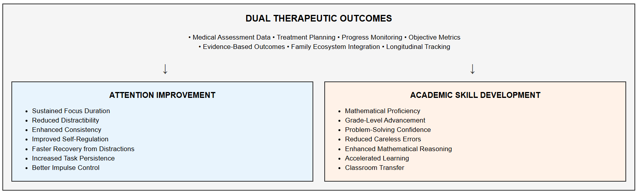

- Explain how the entire invention works to provide the desired solution.
See above

- Explain exactly how/why it solves the current problems; i.e. why it is better than the prior-art; why would us use this rather than the prior art?

Current Problem 1: ADHD Therapy Access Barriers

Traditional Therapy Limitations:
Cost: $100-200/hour excludes most families
Time: 60+ minute sessions plus travel time
Access: Limited specialized ADHD therapists
Measurement: Subjective progress assessment

This invention:
Cost: affordable
Time: 7-20 minute daily sessions fit family schedules
Access: 24/7 availability through web platform
Measurement: Objective performance metrics (math grade) + subject improvement (raising self-esteem, very important)

Current Problem 2: Academic Performance Gaps
Existing Solutions Shortcomings:
- EndeavorRx: Abstract gaming with no academic benefit
- Educational apps: Generic content without ADHD-specific adaptation
- Tutoring: Lacks attention training protocols
- Medication: No skill development, side effects, costly; parents hesitate.

This innovation:
- Dual Outcome Delivery: Simultaneous attention training and math skill development; measurable progress
- Family-Centered Approach: Easy for parents; satisfy the primary parental concern (kids do better in school) + satisfy the secondary parental concerns (automated grading / time saving, automated problem explanation / less hassle, easy to use / no learning curve or lifestyle adjustment needed, affordable / always important, transparent measurement / feels the control, kids’ self-esteem / I found it highly important for my kids)
- Therapeutic Personalization: ADHD-specific difficulty and timing adjustments
- Sustainable over a student's school career

SUPERIORITY OVER PRIOR ART
vs. Traditional ADHD Therapy:
- Accessibility: 24/7 availability vs. appointment scheduling
- Cost: Freemium model vs. $100-200/hour
- Measurement: Objective data vs. subjective assessment
- Academic Integration: Math skill development vs. attention-only focus

vs. EndeavorRx: [!IMPORTANT: this is an important prior art]
- Academic Benefit: Real mathematical learning vs. abstract gaming
- Content Acceptance: Educational focus vs. entertainment resistance
- Transfer Value: Classroom-relevant skills vs. isolated cognitive training
- Family Preference: Academic progress vs. gaming concerns

vs. Educational Apps (Khan Academy, IXL):
- ADHD Specialization: Attention-aware adaptation vs. generic delivery
- Therapeutic Protocol: Clinical intervention vs. standard tutoring
- Behavioral Monitoring: Real-time attention tracking vs. simple progress tracking
- Personalization: ADHD subtype-specific vs. one-size-fits-all

vs. Medication:
- Side Effects: No physical risks vs. appetite/sleep concerns
- Meds are costly

(iv) Explain all the advantages of the present invention (e.g., accuracy, specificity, sensitivity, speed, price, simplicity, ease of use, versatility – everything you can think of).
See above
- Explain both the similarities and differences it has with the old technology.

SIMILARITIES WITH EXISTING SOLUTIONS

Shared with Traditional ADHD Therapy:
- Therapeutic Intent: Both aim to improve attention and focus capabilities
- Behavioral Intervention: Both use structured activities to train attention
- Progress Monitoring: Both track improvement over time
- Professional Oversight: Both can involve clinical supervision

Shared with EndeavorRx:
- Digital Delivery: Both use technology platforms for intervention
- Gamification Elements: Both incorporate engaging, interactive elements
- FDA Consideration: Both designed for therapeutic rather than entertainment purposes
- Attention Training Focus: Both specifically target attention deficits

Shared with Educational Apps:
- Mathematical Content: Both present math problems for solving
- Digital Interface: Both use computer-based problem presentation
- Progress Tracking: Both monitor student performance over time
- Self-Paced Learning: Both allow students to work at their own speed

Shared with Medication:
- ADHD Treatment: Both address core ADHD symptoms
- Clinical Integration: Both can be part of comprehensive treatment plans
- Measurable Outcomes: Both provide quantifiable improvement metrics
- Professional Recommendation: Both may be prescribed by healthcare providers

CRITICAL DIFFERENCES FROM OLD TECHNOLOGY

vs. Traditional ADHD Therapy:

FUNDAMENTAL DIFFERENCES:
- Content Integration: Vinci uses academic mathematical content vs. abstract attention exercises
- Dual Outcomes: Simultaneous attention training and skill development vs. attention-only focus
- Automated Delivery: AI-driven intervention vs. human therapist dependency
- Accessibility: 24/7 online access vs. appointment-based scheduling
- Cost Structure: Freemium model vs. $100-200/hour professional fees
- Measurement Precision: Millisecond timestamp tracking vs. subjective observation
- Session Duration: 3-20 minutes vs. 60+ minute sessions

METHODOLOGICAL DIFFERENCES:
- Real-Time Adaptation: Immediate difficulty adjustment vs. session-to-session changes
- Behavioral Analytics: Comprehensive data capture vs. limited observation notes
- Standardization: Consistent protocol delivery vs. therapist variability
- Scalability: Unlimited concurrent users vs. one-on-one limitations

vs. EndeavorRx:

CORE DISTINCTIONS:
- Academic Value: Mathematical skill development vs. abstract cognitive training
- Content Relevance: Classroom-applicable learning vs. isolated gaming tasks
- Family Acceptance: Educational focus vs. entertainment-based resistance
- Transfer Benefits: Direct academic improvement vs. uncertain skill transfer
- Multi-Agent Architecture: Three specialized AI systems vs. single-focus gaming engine

THERAPEUTIC APPROACH:
- Problem-Based Learning: Mathematical challenges vs. abstract visual-motor tasks
- Educational Integration: Aligns with school curriculum vs. separate gaming activity
- Parental Preference: Academic progress priority vs. gaming concerns
- Long-Term Value: Permanent mathematical knowledge vs. temporary attention improvement

vs. Educational Apps (Khan Academy, IXL):

ADHD-SPECIFIC INNOVATIONS:
- Attention Monitoring: Real-time behavioral tracking vs. simple progress logging
- Therapeutic Protocols: Clinical intervention strategies vs. standard educational delivery
- Adaptive Difficulty: ADHD-aware adjustment vs. generic progression
- Subtype Personalization: Inattentive vs. hyperactive customization vs. one-size-fits-all
- Cognitive Load Management: Therapeutic dosing vs. unlimited problem presentation

BEHAVIORAL INTEGRATION:
- Attention State Detection: Identifies focus, drift, distraction states vs. basic completion tracking
- Intervention Triggers: Automatic re-engagement protocols vs. passive content delivery
- Clinical Data: Medical-grade metrics vs. educational analytics
- Therapeutic Timing: Optimized session lengths vs. unlimited study time

vs. Medication:

MECHANISM DIFFERENCES:
- Skill Development: Builds permanent mathematical abilities vs. temporary symptom management
- Learning Integration: Addresses academic gaps vs. attention symptoms only
- Side Effect Profile: No physical risks vs. appetite, sleep, growth concerns
- Dependency Model: Self-contained improvement vs. ongoing medication requirement
- Holistic Approach: Combines attention training with academic progress vs. symptom-only focus

OUTCOME DISTINCTIONS:
- Permanent Benefits: Mathematical knowledge retention vs. medication-dependent improvement
- Academic Remediation: Directly addresses learning gaps vs. enables learning capacity
- Family Preference: Educational progress vs. medication concerns
- Long-Term Independence: Self-sustaining skill development vs. ongoing pharmaceutical dependency

8). What is the key NOVELTY of your invention? I.e., what is really new? What elements most distinguish your invention for the prior art? This is very important.

1. NOVEL Multi-Agent AI Architecture for ADHD Therapy
First-ever deployment of three specialized AI agents working in concert for ADHD therapeutic intervention:
- Detection AI Agent - Real-time behavioral pattern analysis during math tasks
- Intervention AI Agent - Automated therapeutic protocol delivery
- Economy AI Agent - Evidence-based reinforcement and progress tracking
Prior Art: Existing digital therapeutics use single-algorithm approaches or human-delivered therapy

2. NOVEL Academic Content Integration with Therapeutic Intervention
Dual-purpose mathematical problem-solving tasks that simultaneously:
- Deliver therapeutic attention training
- Advance academic mathematical skills
- Provide measurable outcomes in both domains
Prior Art: Current cognitive training platforms use abstract, non-academic tasks with no educational value

3. NOVEL Real-Time ADHD Subtype Detection and Adaptive Protocols
AI-powered real-time identification of:
- ADHD subtypes (Inattentive, Hyperactive-Impulsive, Combined)
- Dynamic attention states (Optimal Focus, Attention Drift, Distraction, Cognitive Fatigue)
- Automatic deployment of subtype-specific therapeutic protocols
Prior Art: Existing platforms use one-size-fits-all approaches without subtype differentiation or real-time adaptation

4. NOVEL Behavioral Pattern Analysis During Academic Tasks
Continuous monitoring and analysis of:
- Response time variability patterns
- Accuracy decline trajectories
- Self-correction behaviors
- Engagement timing analysis
- All analyzed within mathematical problem-solving context
Prior Art: Traditional assessment relies on separate, non-academic cognitive tests

5. NOVEL Precision Therapeutic Dosing Through Cognitive Load Management
Automated therapeutic dosing that:
- Reduces difficulty when accuracy drops below therapeutic thresholds (e.g., 70%)
- Increases complexity to maintain optimal challenge zones
- Delivers therapy through academic content rather than abstract exercises
Prior Art: Manual adjustment by human therapists with subjective assessment

6. NOVEL Automated Safety and Clinical Integration
Built-in automated systems for:
- Parental notification triggers
- Human oversight activation
- Clinical-grade outcome measurements for medical assessment
- Process-focused token systems with evidence-based reinforcement
Prior Art: Limited safety protocols and non-clinical outcome measures

7. NOVEL Cost-Accessibility Through AI Automation
Complete automation of therapeutic delivery that:
- Eliminates $100-200/hour human therapist costs
- Reduces 1+ hour sessions to 7-20 minute daily sessions
- Provides objective, measurable outcomes instead of subjective reports
Prior Art: Expensive human-delivered therapy with unmeasurable outcomes

8. NOVEL Attention State-Based Intervention Protocols
Specific intervention protocols tailored to detected attention states:
- Optimal Focus State → Challenge protocol with complexity increase
- Attention Drift State → Re-engage protocol with visual variety
- Distraction State → Mind break protocol with simplified presentation
- Cognitive Fatigue State → Wrap-up protocol with success completion
Prior Art: Generic interventions not responsive to real-time attention states

SIGNATURES AND WITNESSES (complete whatever is appropriate below)

INVENTOR: Fei Fang
DATE: June 26
SIGNED AT (City and State): Hong Kong

FOR UNIVERSITY & CPORPORATE CLIENTS:

WITNESSED, READ AND UNDERSTOOD BY:
NAME:
DATE:
SIGNED AT (City and State)

NOTE: ALL SIGNATURES BELOW MUST BE WITNESSED BY A PERSON WHO MEETS THE FOLLOWING CRITERIA: 1) The witness must not be an inventor. 2) The witness has the technical background to understand the invention and how it works. 3) The witness has read this document and understands the invention and how it works.

Bell IP Law​
San Francisco, California
415-752-4085
Website: www.bell-iplaw.com

